CARRELLO ALIEXPRESS EXPLORER:

[BMS](https://a.aliexpress.com/_EwXeVGt)

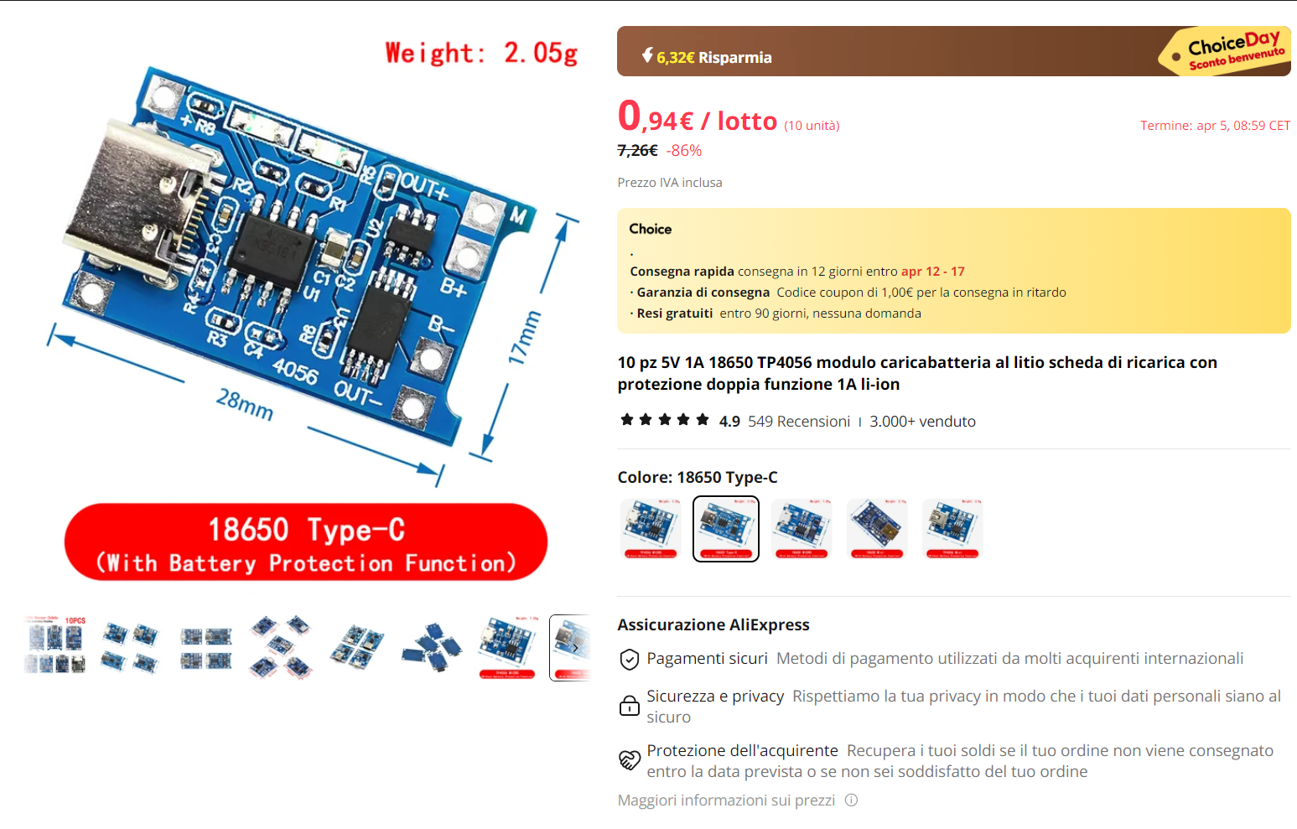

[ARDUINO](https://a.aliexpress.com/_EzwPzbL) (USB C oppure USB MINI)

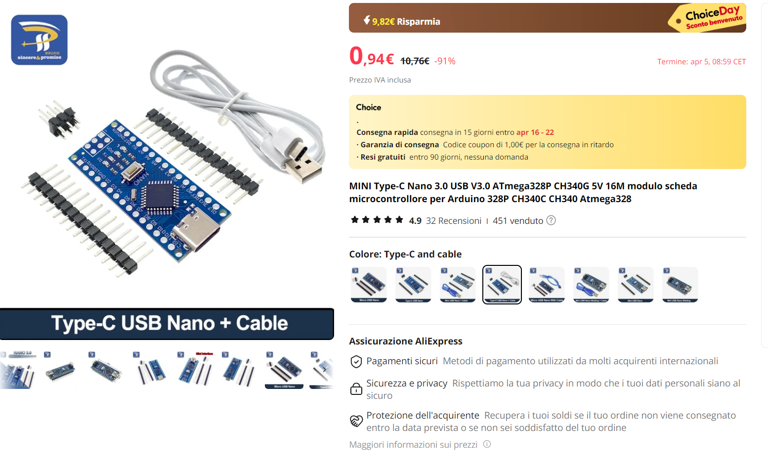

[RC522](https://a.aliexpress.com/_EGaGKa9)

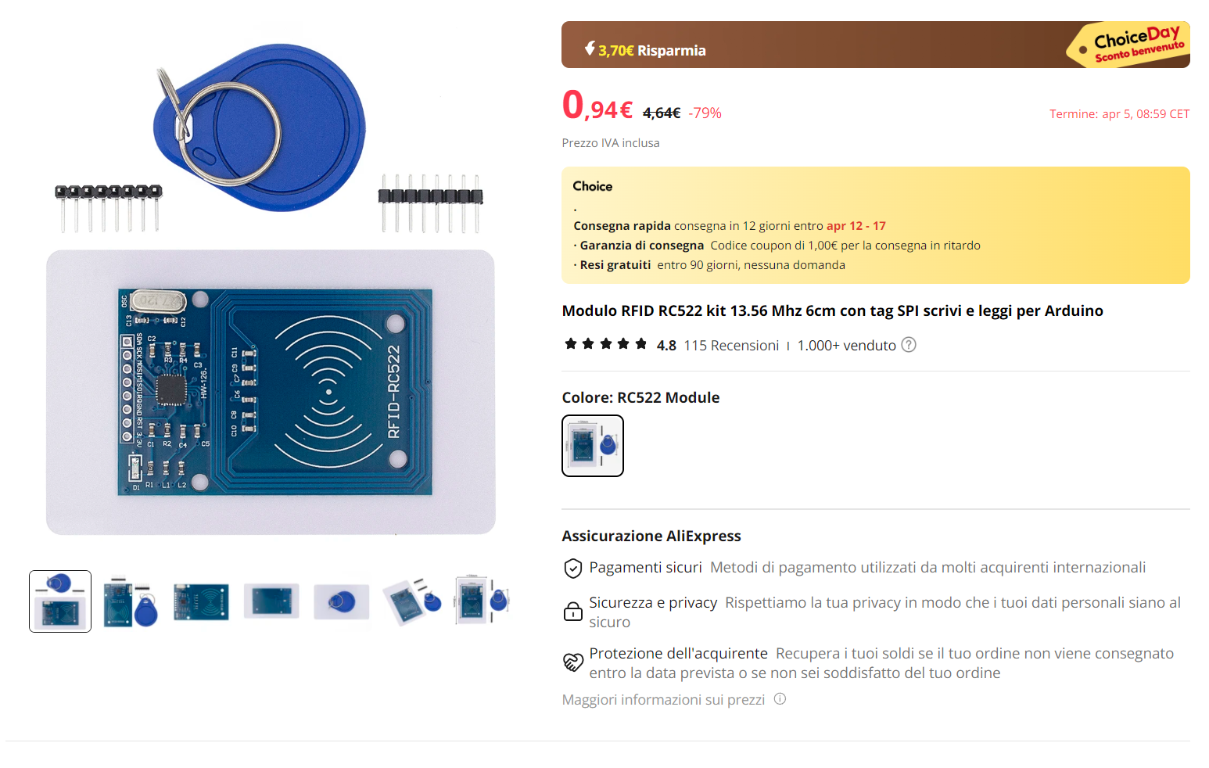

[RC522 MINI](https://a.aliexpress.com/_Ez5M92p)

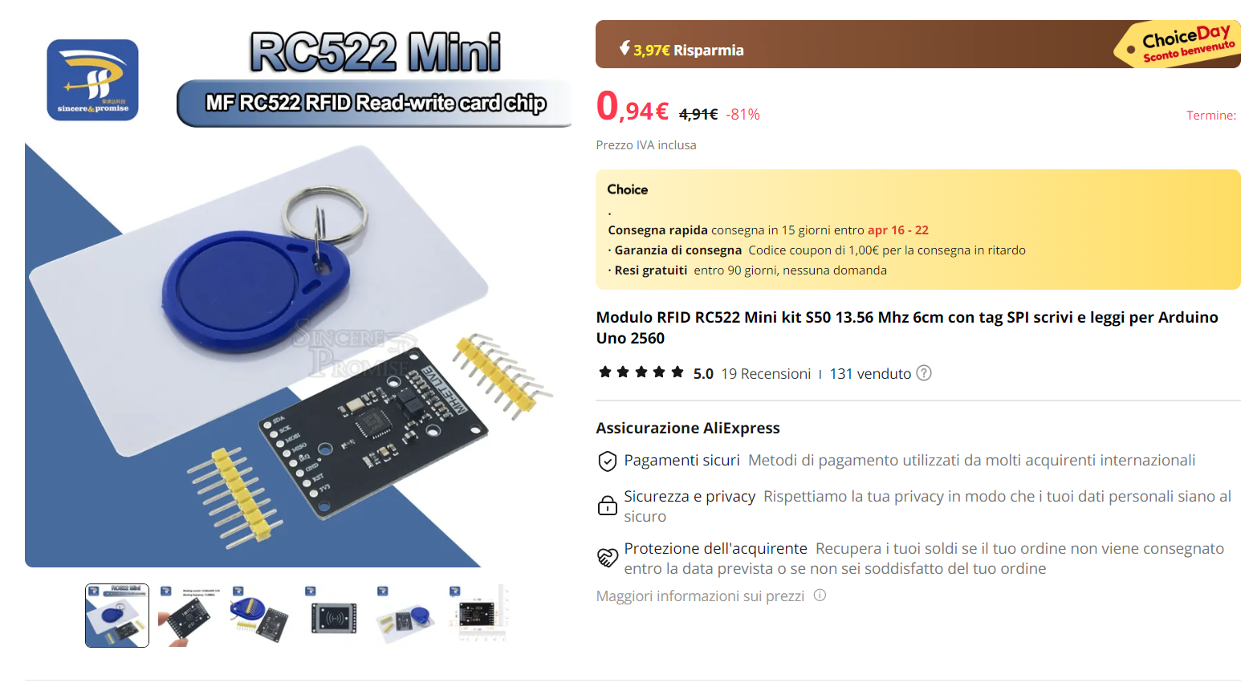

[PULSANTI](https://a.aliexpress.com/_Ez2mlJP)

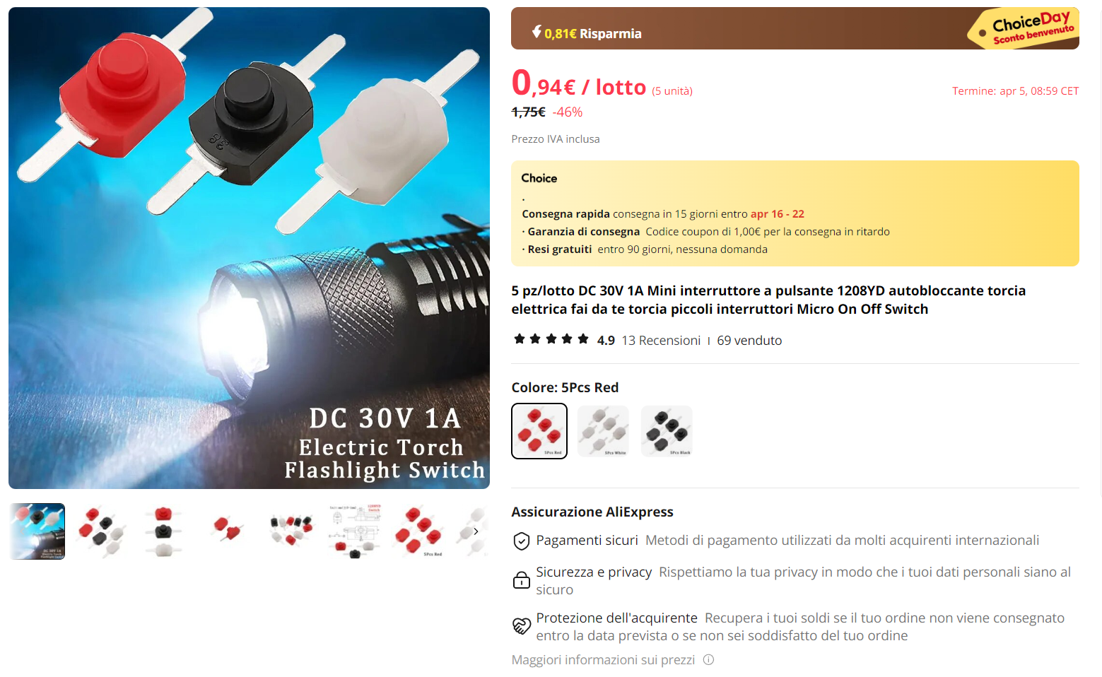

[BOTTONI](https://it.aliexpress.com/item/1005005845072975.html?algo_pvid=c4da7e57-daf0-4f56-8541-4159e9401c5d&algo_exp_id=c4da7e57-daf0-4f56-8541-4159e9401c5d-0&pdp_npi=4%40dis%21EUR%211.73%210.94%21%21%211.82%210.99%21%40210385db17119973205702395e61cb%2112000034553364521%21sea%21IT%212736040089%21AB&curPageLogUid=BhdRkBJ4N9K5&utparam-url=scene%3Asearch%7Cquery_from%3A)

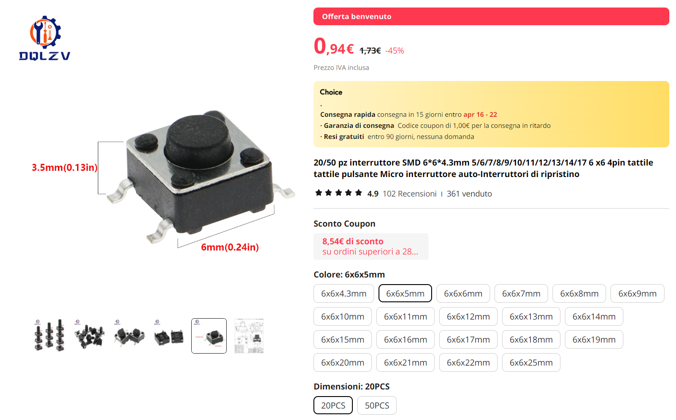

[OLED](https://a.aliexpress.com/_Ev1agqz)

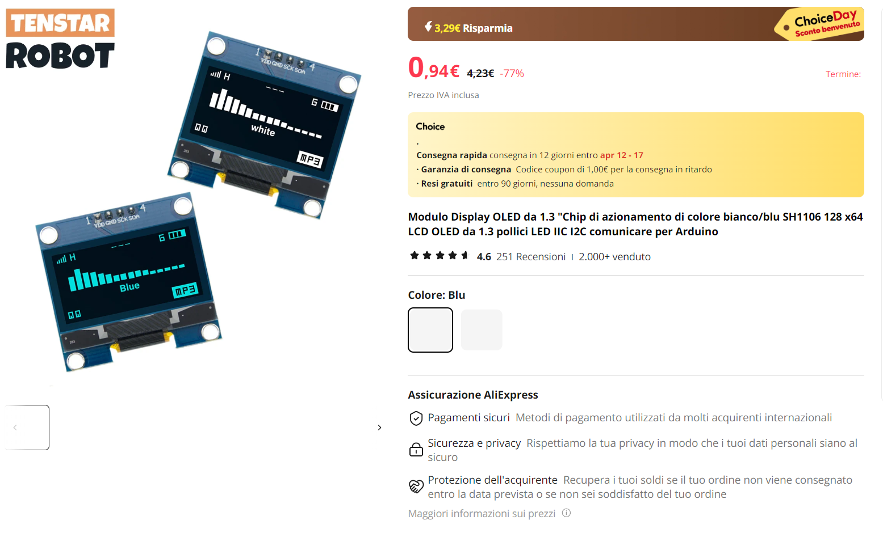

[BATTERIA](https://it.aliexpress.com/item/1005004305310717.html?spm=a2g0o.detail.pcDetailTopMoreOtherSeller.3.541144d3kZwg0e&gps-id=pcDetailTopMoreOtherSeller&scm=1007.40000.327270.0&scm_id=1007.40000.327270.0&scm-url=1007.40000.327270.0&pvid=686a4c1e-dbb8-48f7-bea4-461c2b29b866&_t=gps-id:pcDetailTopMoreOtherSeller,scm-url:1007.40000.327270.0,pvid:686a4c1e-dbb8-48f7-bea4-461c2b29b866,tpp_buckets:668%232846%238112%231997&pdp_npi=4%40dis%21EUR%217.44%211.58%21%21%217.86%211.66%21%40211b61a417094868233843952e3824%2112000028693369573%21rec%21IT%212736040089%21AB&utparam-url=scene%3ApcDetailTopMoreOtherSeller%7Cquery_from%3A&search_p4p_id=202403030927035695038955990261016820_2)

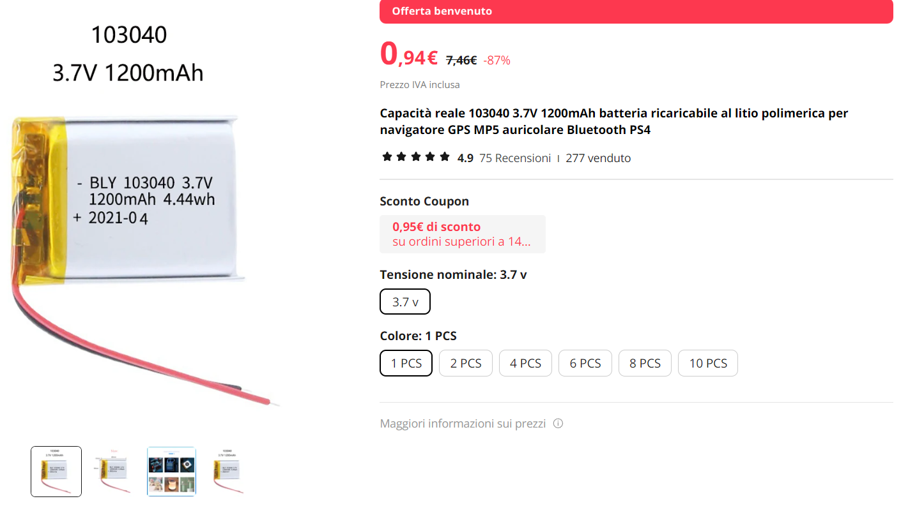

**RC522**:

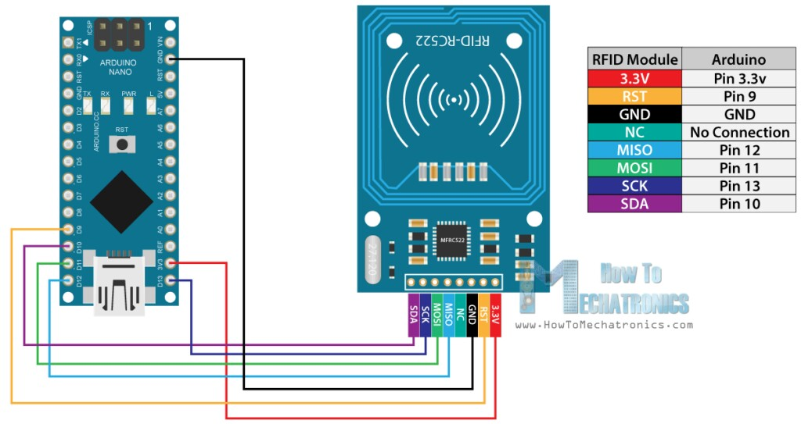

RST Reset - D9

SPI SS - D10

SPI MOSI - D11

SPI MISO - D12

SPI SCK - D13

**OLED**:

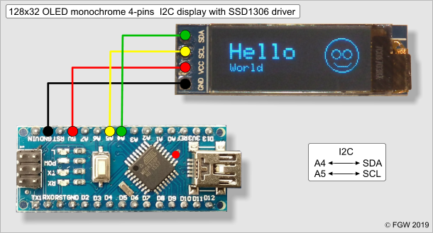

GND - GND

VCC - 5V

SCL - A5

SDA - A4

**BATTERY:**

+ passa per BMS, INTERRUTTORE e poi pin VIN

- passa per BMS, e poi pin GND

**2 PULSANTI:**

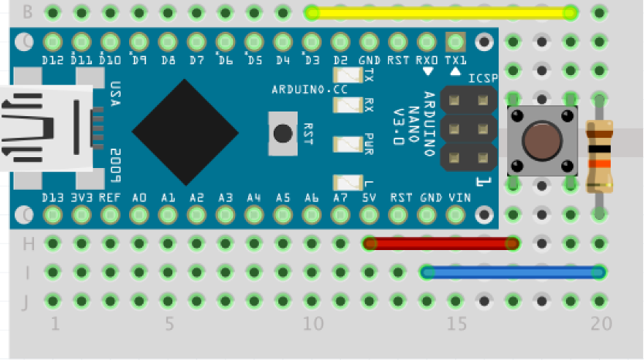

5 V - una gamba del pulsante

Gnd - un ramo del resistore

D2 - l'altro ramo del resistore

(UN PULSANTE NEL D2 E UNO NEL D3)